HARVELELECTRIC ELECTRONIC STORE

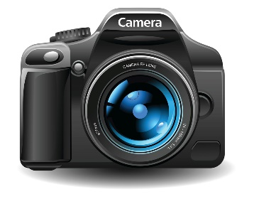

Wi-Fi Waterproof Action Camera -4K Ultra HD 12MP, 2" Screen

Brand: Camera

**Price: $805**

Was ~~$870~~ 54%

+ shipping only for V.V.I.P clients.

## **Product details**

Sports Camera with 4K Ultra HD 1080P: This sports camera with 4K Ultra HD 1080P that provide stunning video quality and 2" display screen to live preview what you shoot, Capture every incredible moment with 720p at 120fps.

Small Tips for Using Our 4k Action Camera

Please use the real high speed class 10 tf card for our sports camera. and the max support 32G, usually use 8G,16G is better.

If TF card used before, then when you insert the card into the 4k camera, please choose "format" first to use.

If video can't read on computer, please check the video on action camera if can read or not. If can read on sports camera, then can try to change computer player. If can't read on 4k camera but can recode that is the card problem. or also can connect wi-fi for the action camera and phone, then open video on phone to see if can read or not .(connect wi-fi by app ,not by "setting")

Waterproof DV Camcorder for Enjoying Your Underwater World: The waterproof camera with solid waterproof case, allowing the action camera shooting up to 30 meters under water. This 4K underwater camera is wearable and mountable: enables immerse capture during your favorite activities: surfing, diving, snorkeling, biking, and driving.

Wi-fi Action Camera to Share Video Freely: The sports camera with wi-fi, You can easily open the action camera wi-fi and connect it with your mobile or tablet by app Camking. It allows you to monitor in real time, review videos/photos on mobile and instantly share on social media.

**Wi-Fi Connectivity**: Simple to Setup and Use for the Wifi Action Camera: The Wi-Fi compatibility makes it simple to send files over to your smart devices, control your action camera from a distance and playback the captured footage. With an easy to use app available for Android or iOS devices, you can easily download and share your footage online or with your friends, family and fans.

## **Specifications**

## **KEY FEATURES**

* High Definition Support:1080P (Full-HD)
* Battery Capacity: 900MAH
* Charging Time: About 2 hours
* Video Format Card Type: MicroSD / TF
* Recording Time: 1080p/ About 100 minutes
* Package: Yes

## **SPECIFICATIONS**

* **SKU**: GE779EL0SYRPMNAFAMZ
* **Product Line**: Mercy concept
* **Model**: N/A
* **Production Country**: China
* **Size (L x W x H cm)**: N/A
* **Weight (kg)**: 0.4
* **Color**: black
* **Main Material**: N/A
* **Display Size (inches)**: 0.0
* **Internal Memory(GB)**: 0
* **Memory Size (GB)**: 0
* **Megapixels**: 12.0